What classes will allow the following code snippet to compile?

Var is = new BufferedInput…z.txt

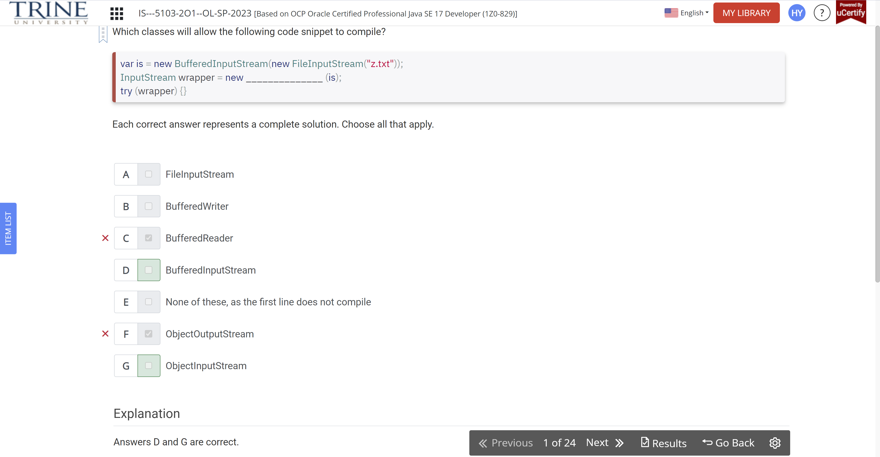

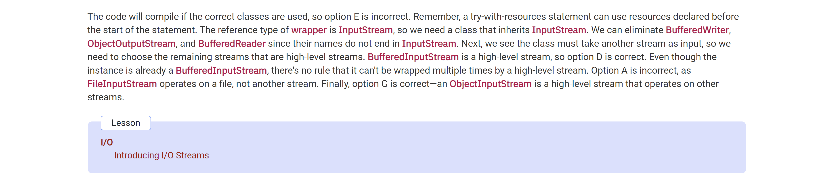

What are some possible results of executing the following code?

Var x = Path.of(“/animals/…”)

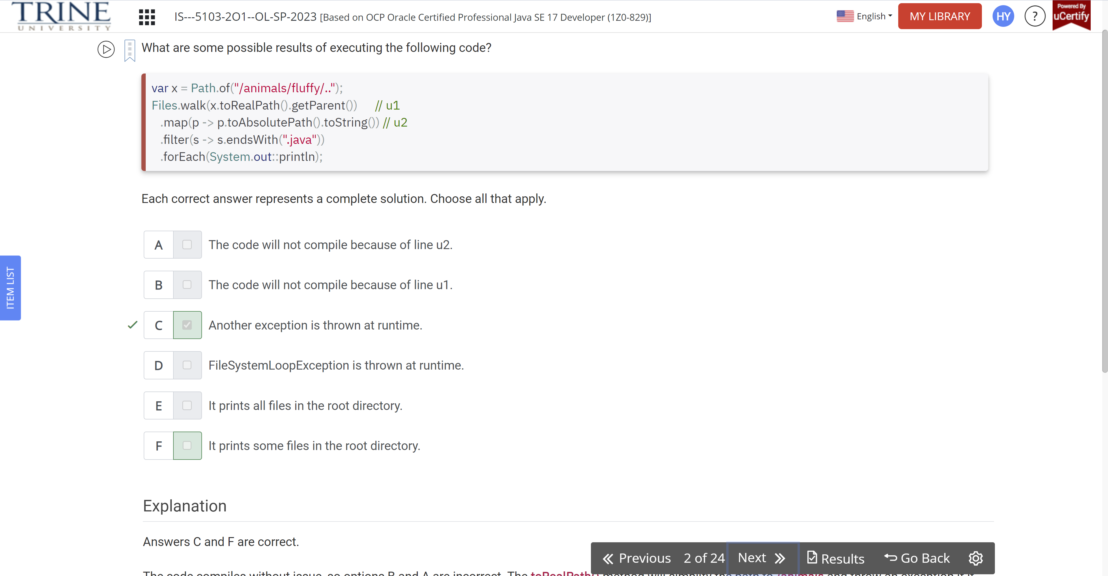

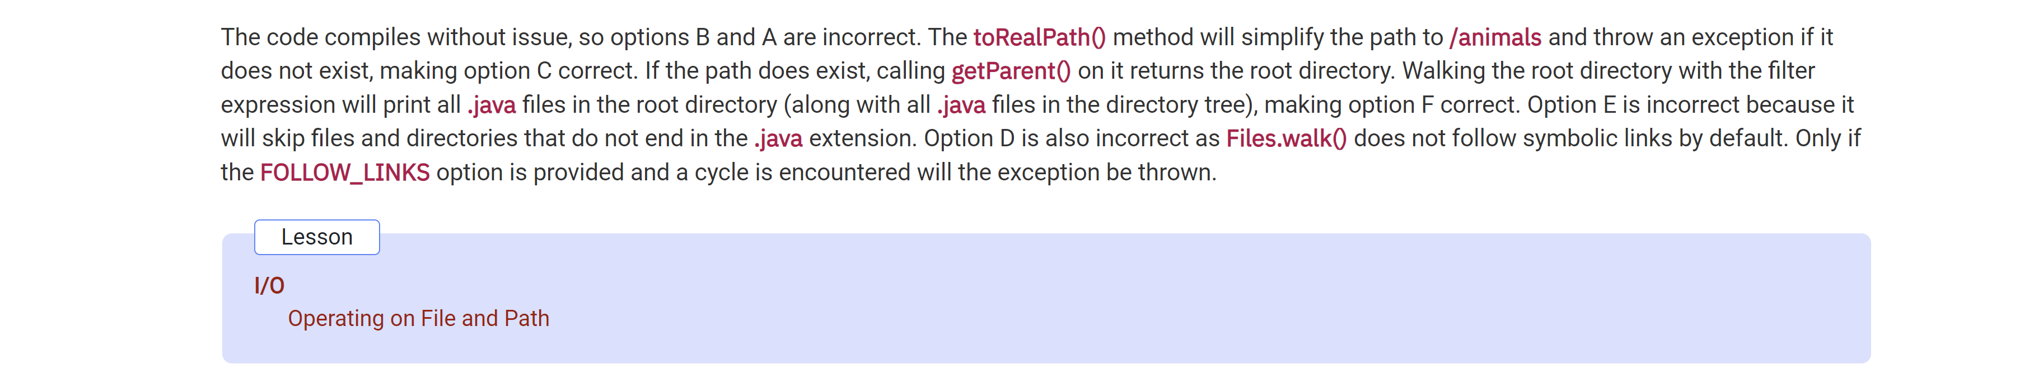

For which values of path sent to this method … output Success?

Void removeBadFile(Path path)

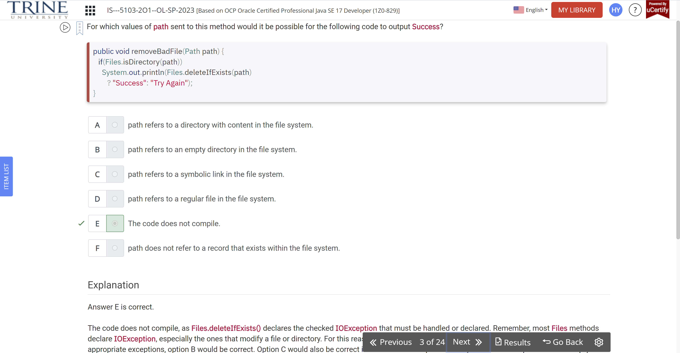

Assuming that / is the root directory within the file system, which of the following are true statements?

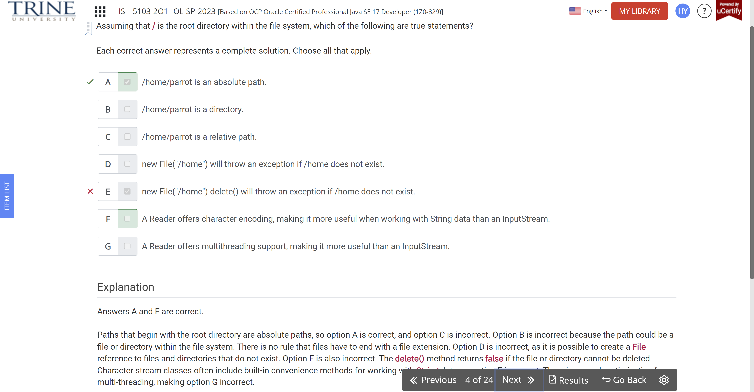

Which of the following fields will be null after an instance of the class on line 17 … ObjectOutputStream …

Public class Zebra …

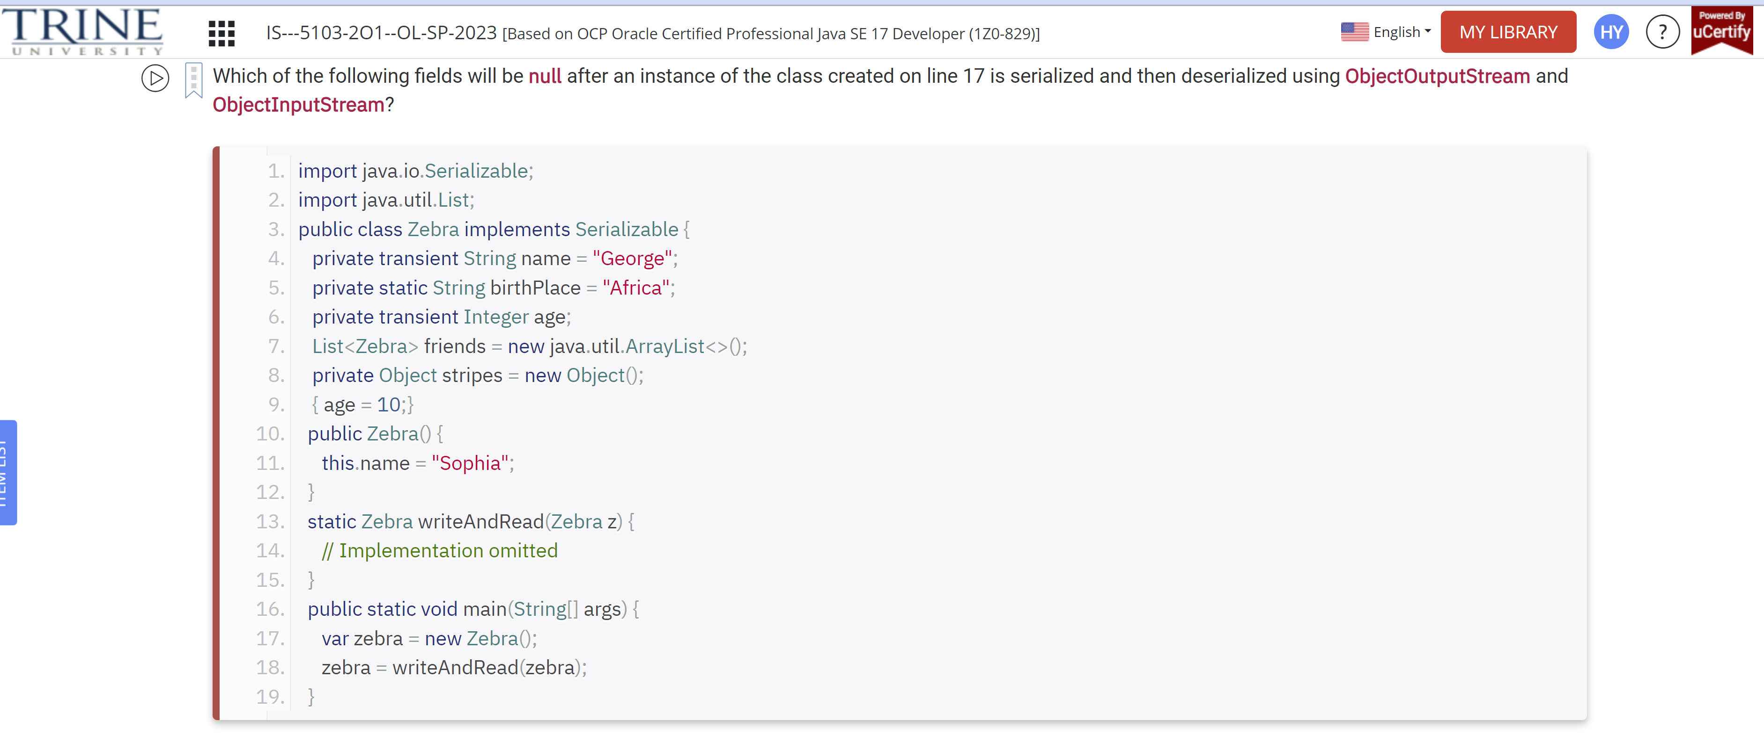

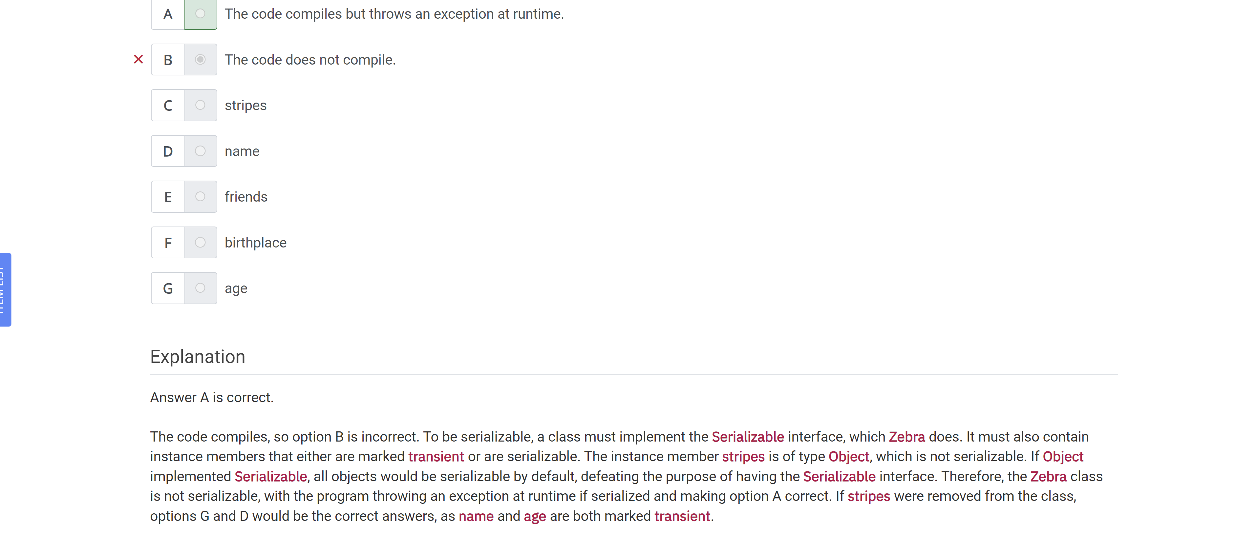

Which of the following are true statements about serialization in Java?

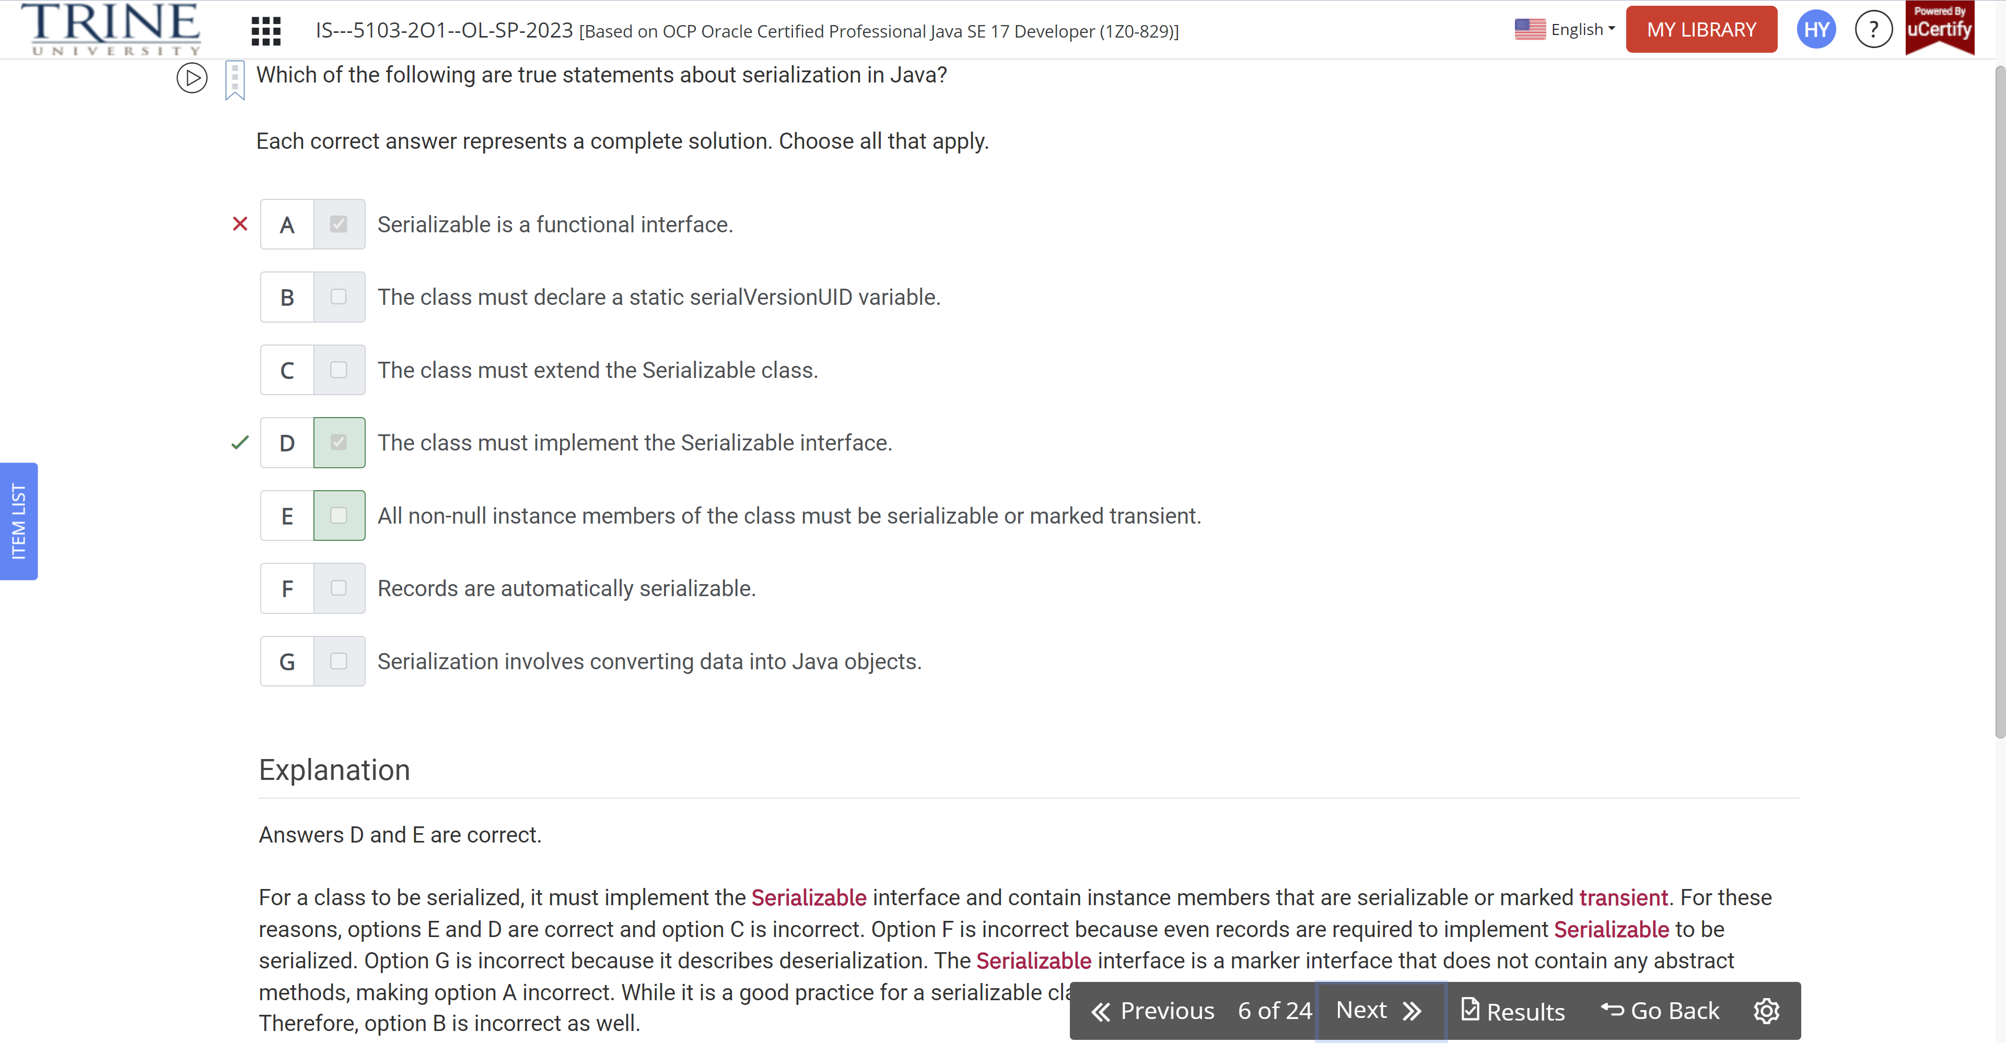

Which of the following correctly create Path instances?

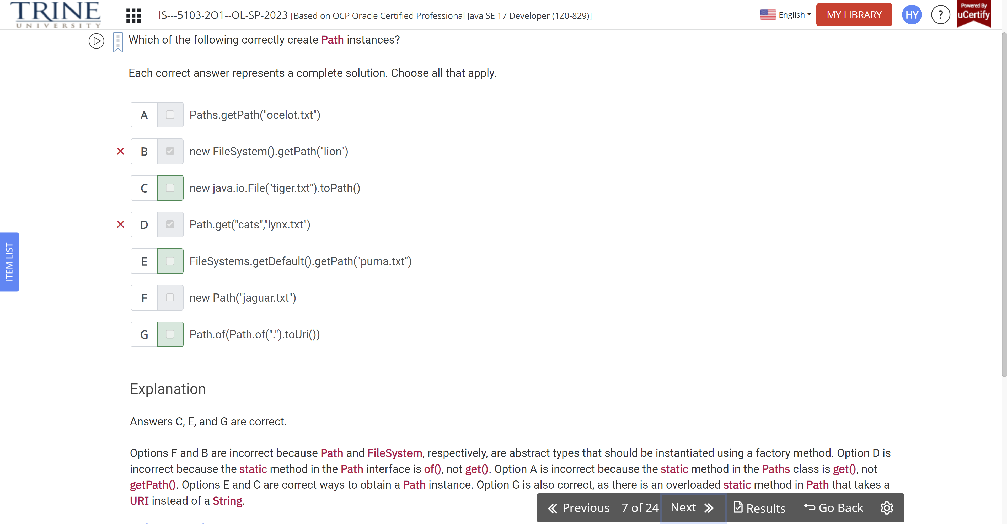

Assume that /monkeys exists as a directory containing …

Var f = Path.of(“/monkeys”);

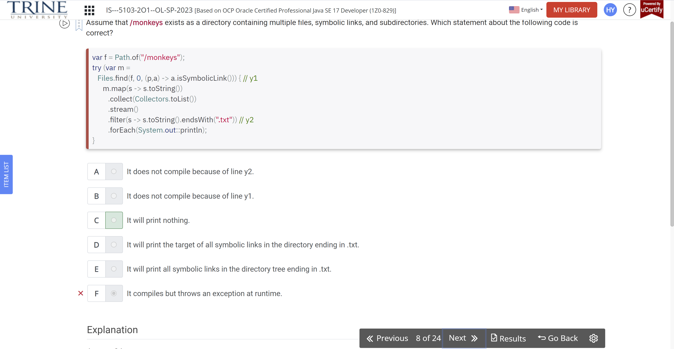

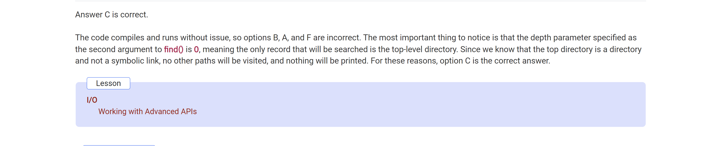

What are possible results of executing the following code?

Static main throws IOException …

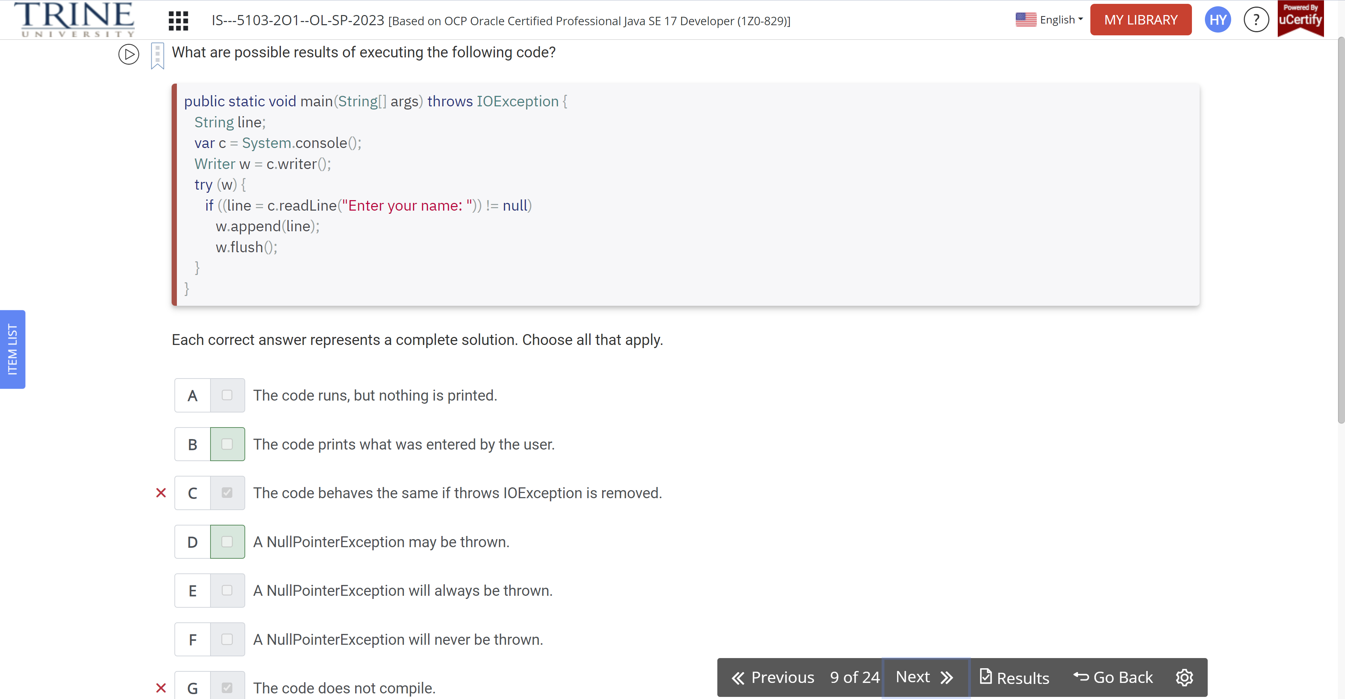

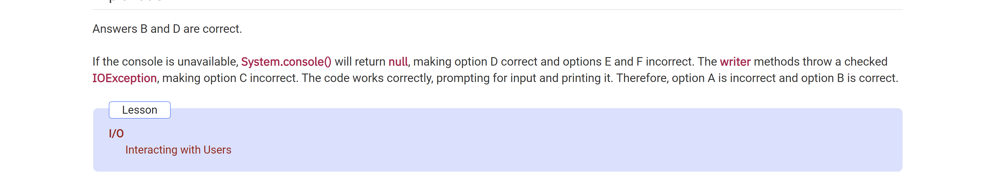

Given the following method, which statements are correct?

Void copyFile(…)

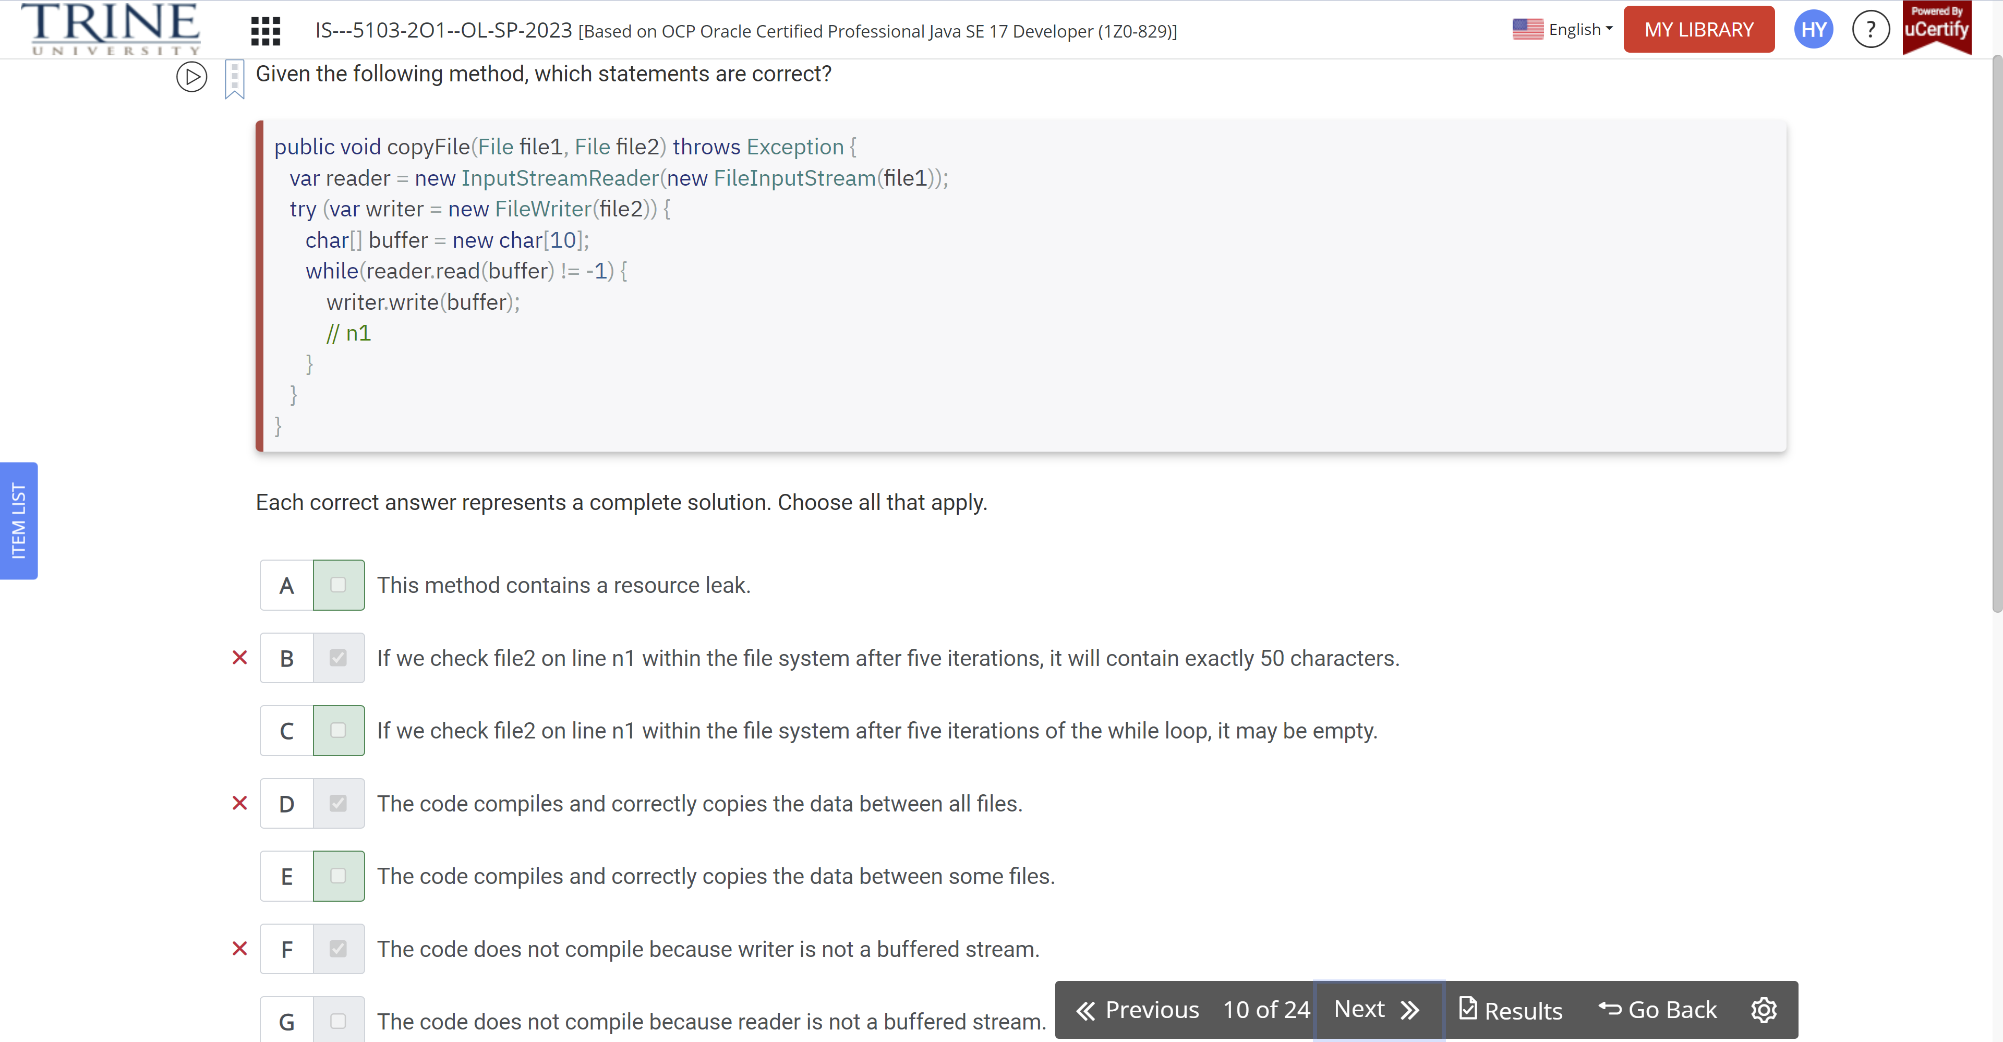

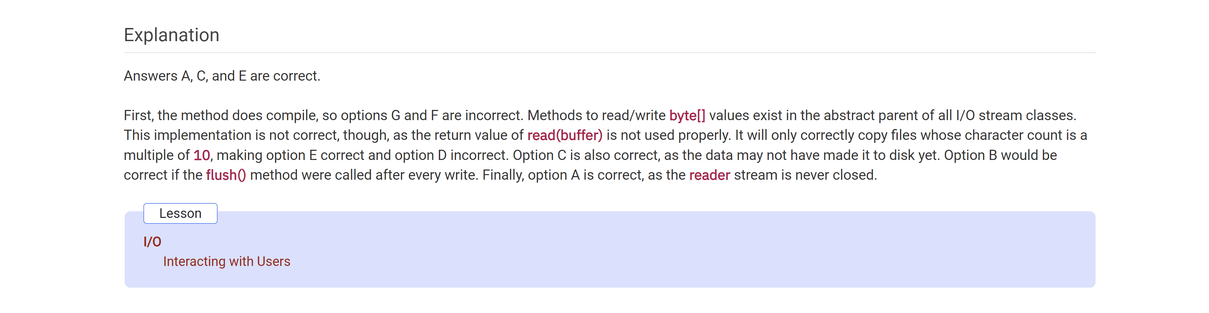

Which of the following statements are true?

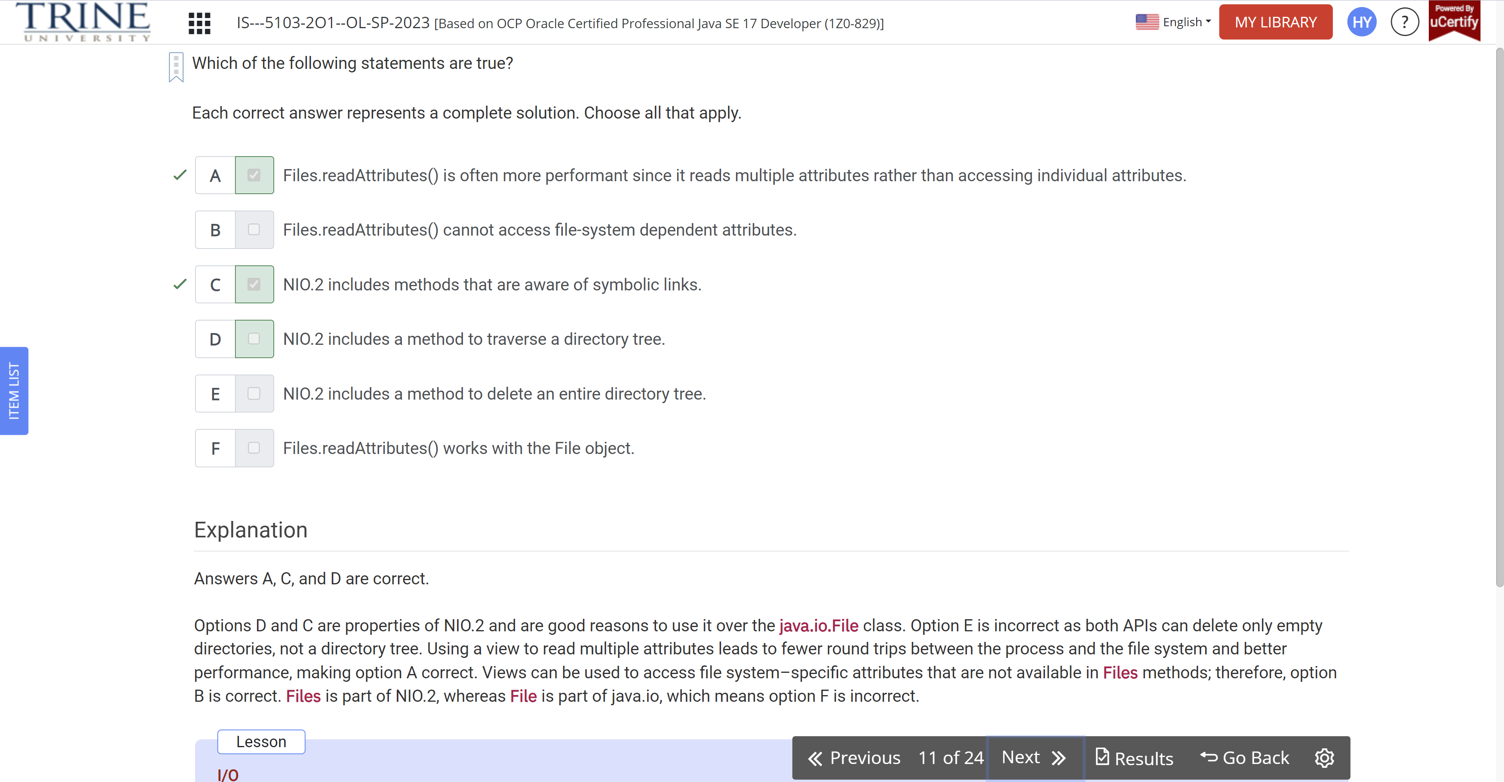

Assuming that the directories and files referenced exists and …

Var p1 = Path.of(lizard

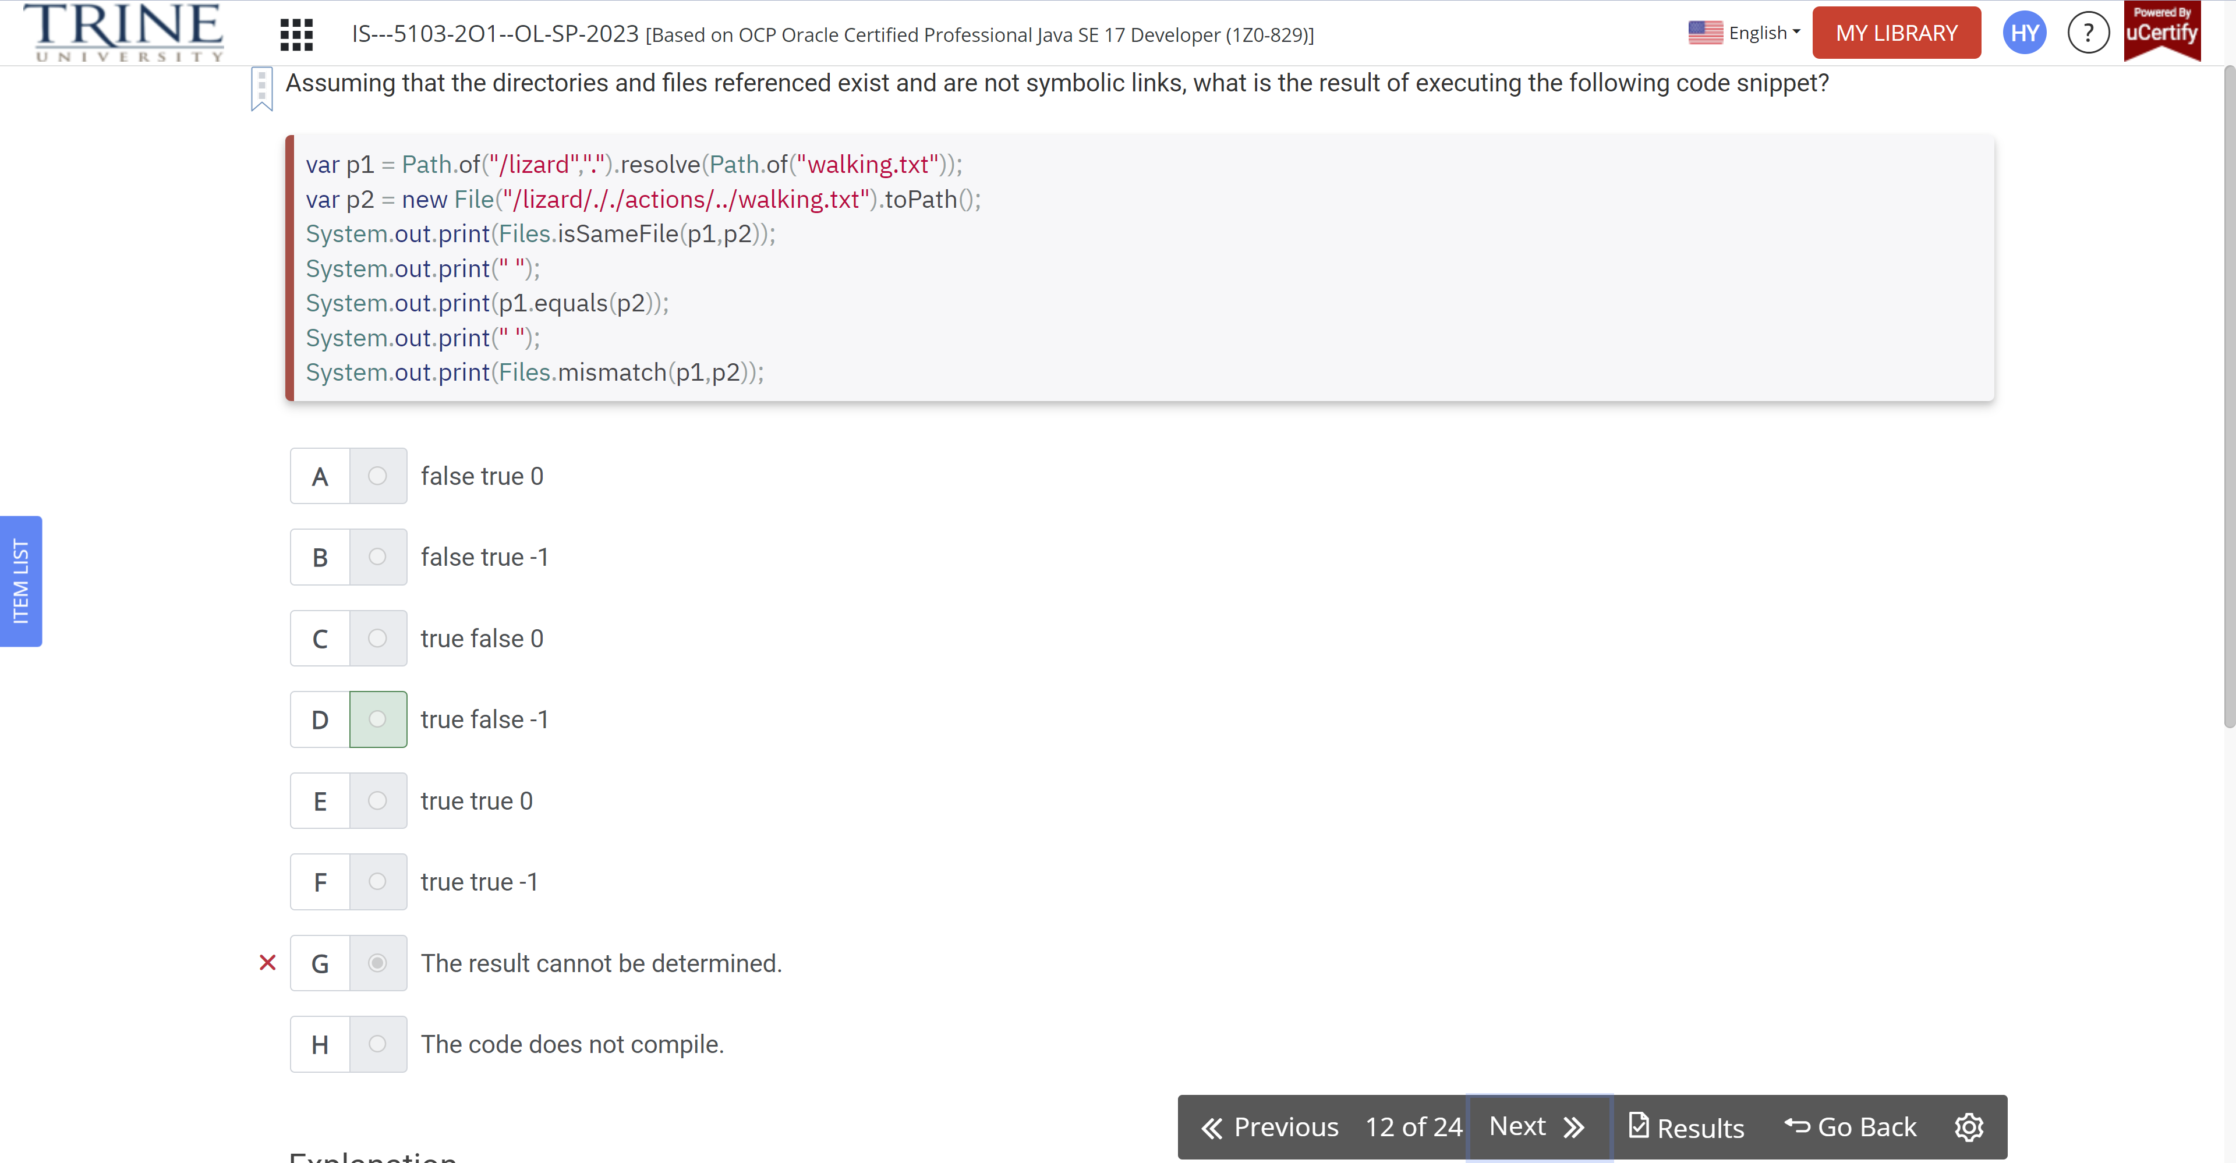

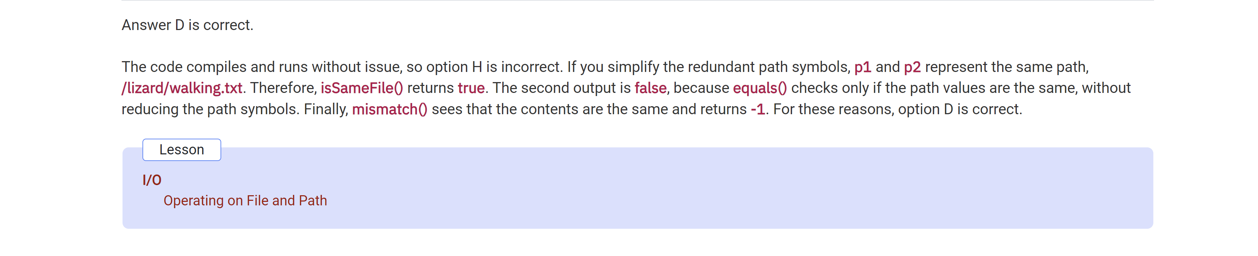

What would be the value of name if the instance of Eagle created in the main()..

Class bird …

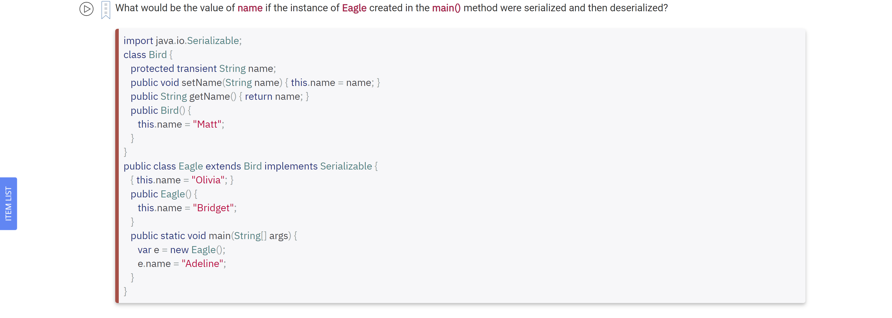

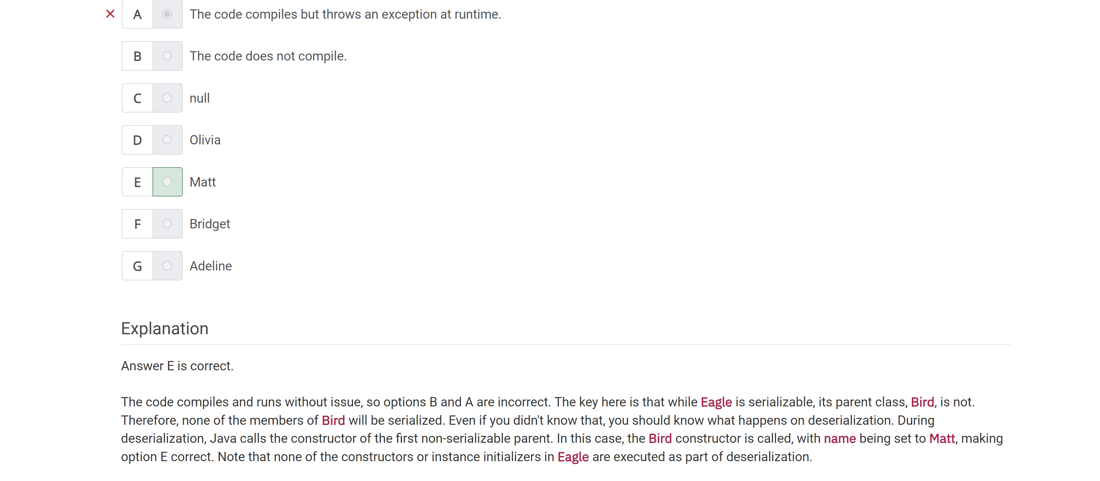

Suppose that you need to read text data from a file and want the data … java.io stream classes …

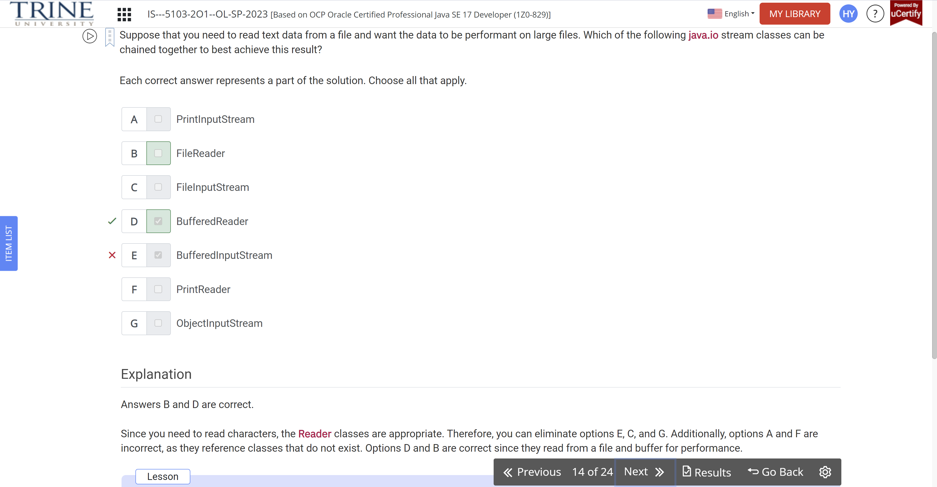

Assuming zoo-data.txt exists and is not empty, what statements about the following method are correct?

Echo() throws IOException…

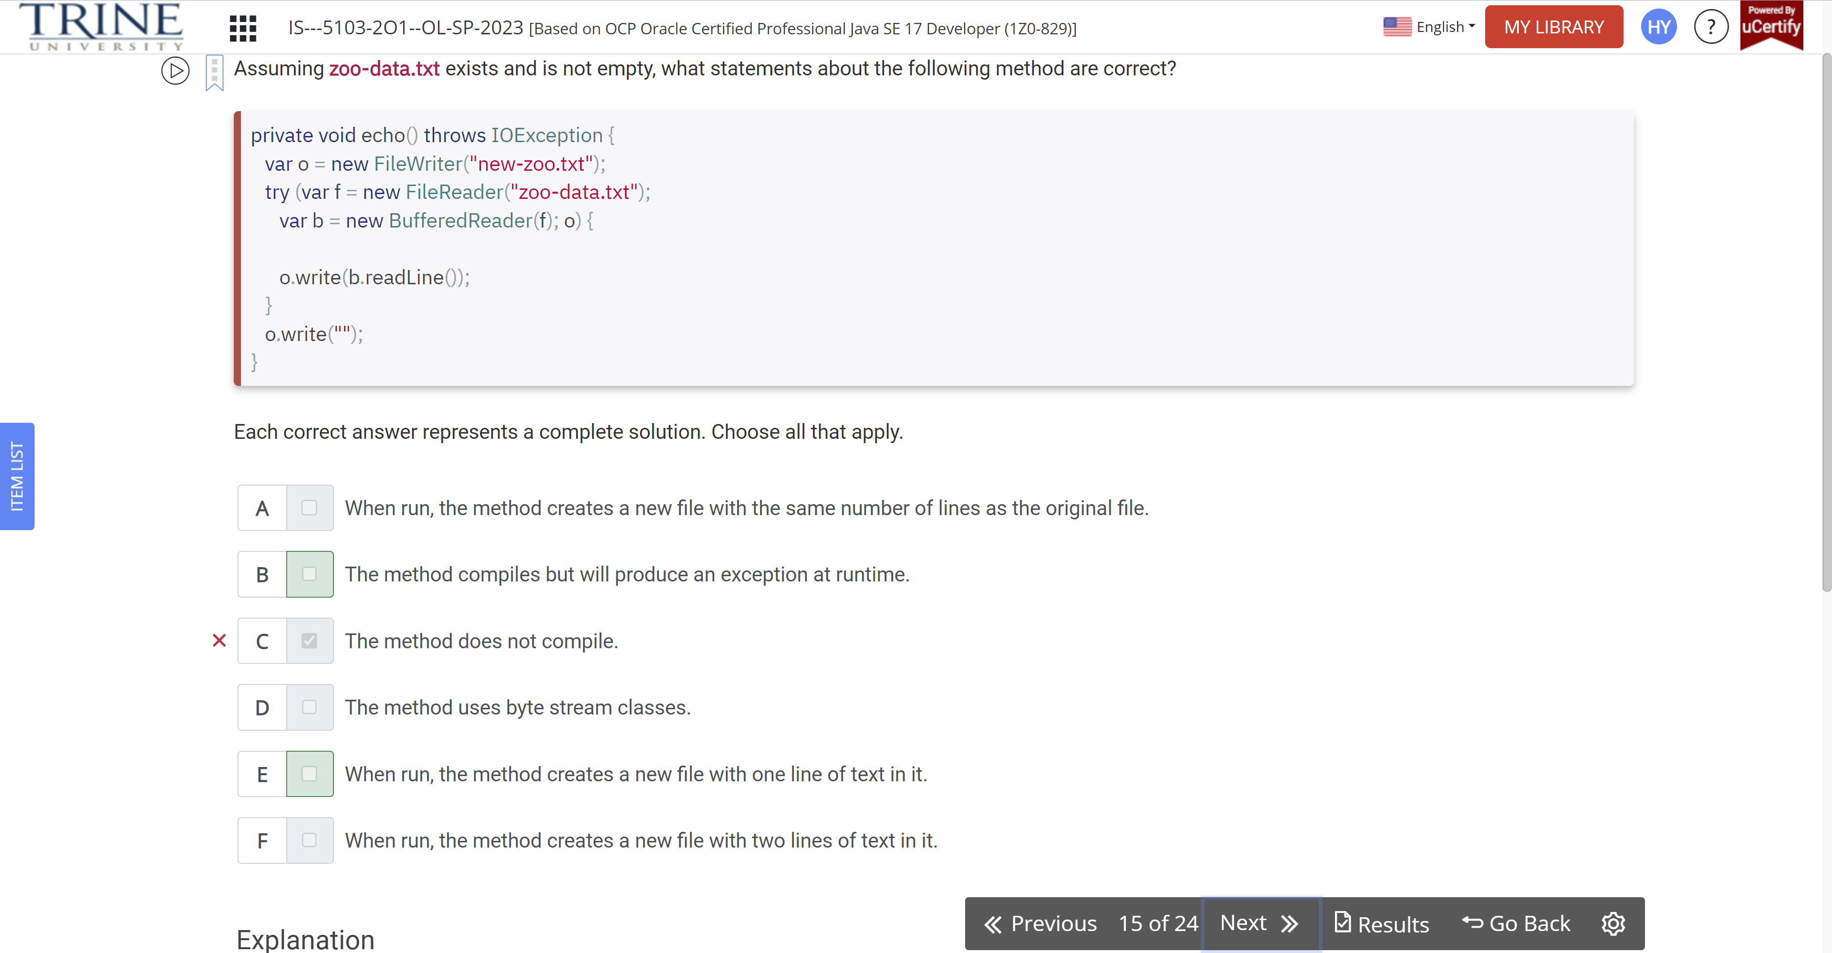

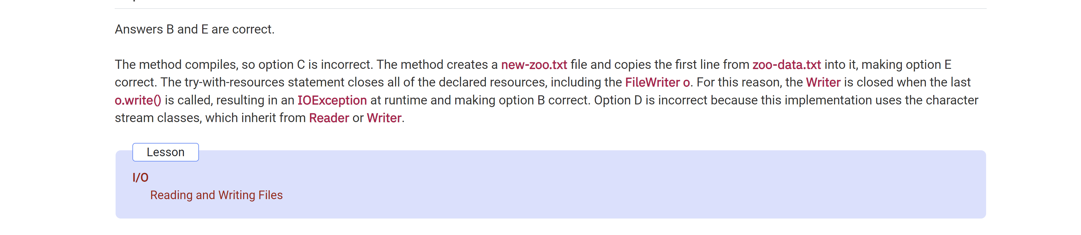

Assume that reader is a valid stream whose next characters are PEACOCKS…

Var sb = new StringBuilder();

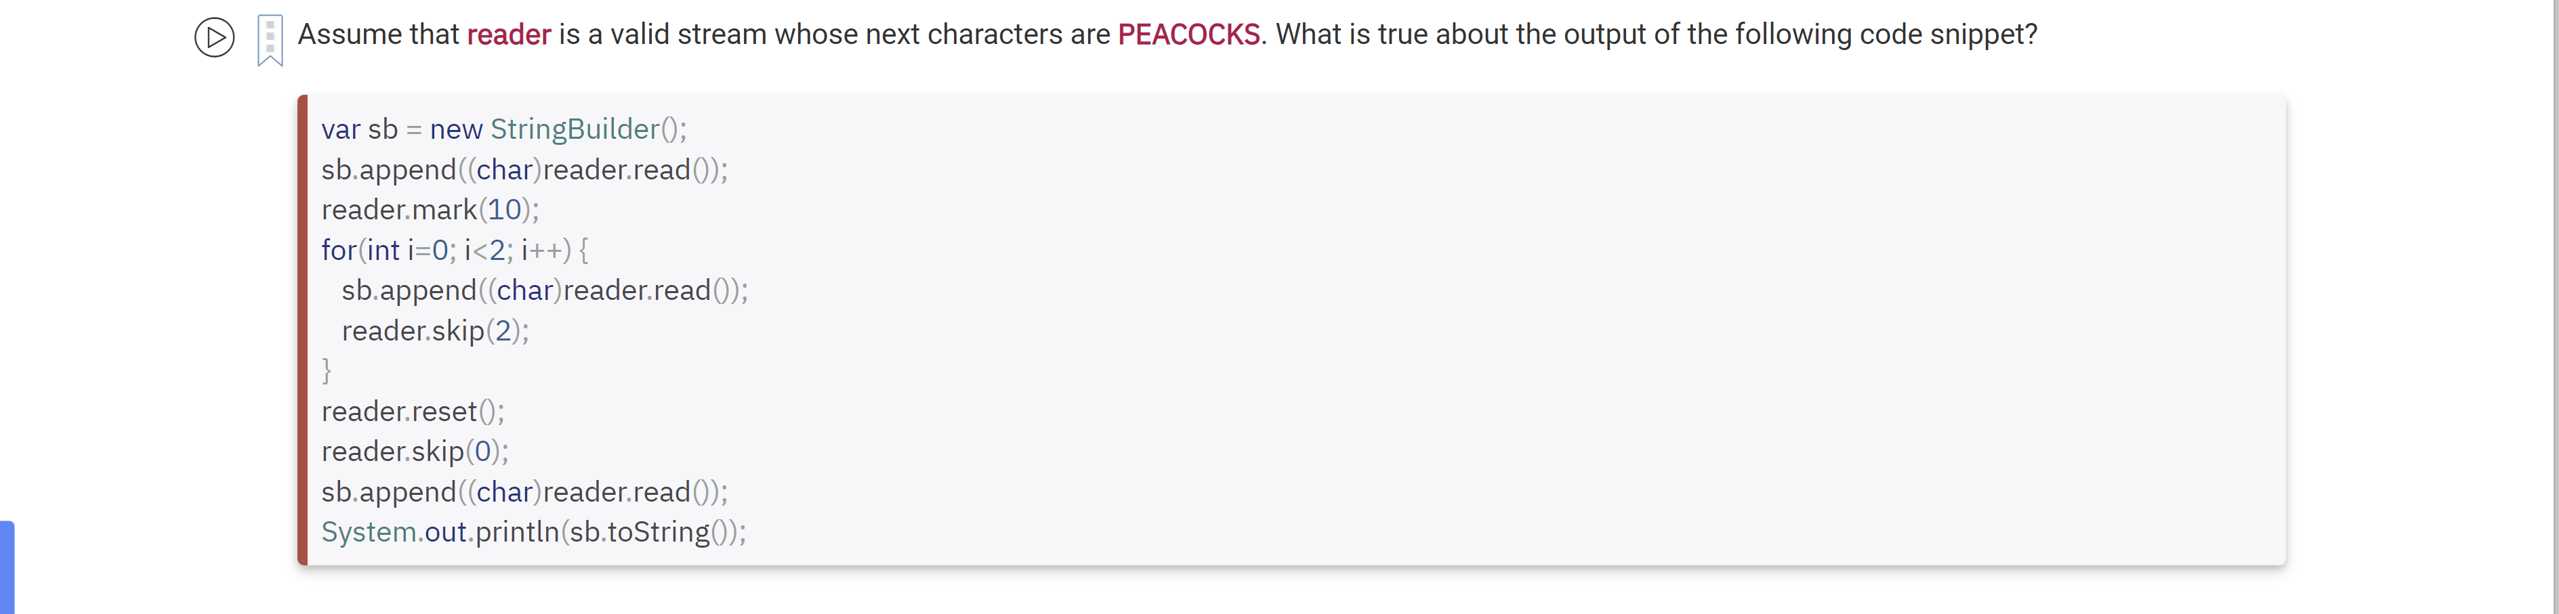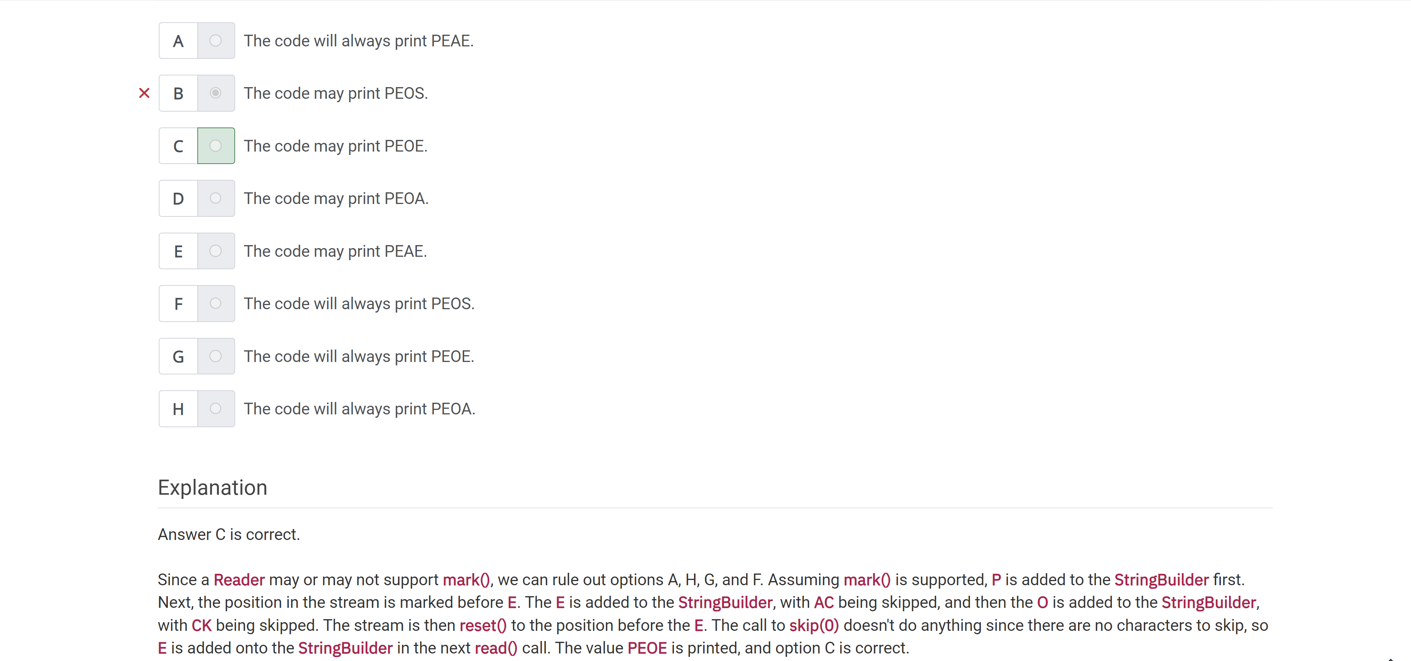

Which class would be best to use to read a binary file into a valuJava object?

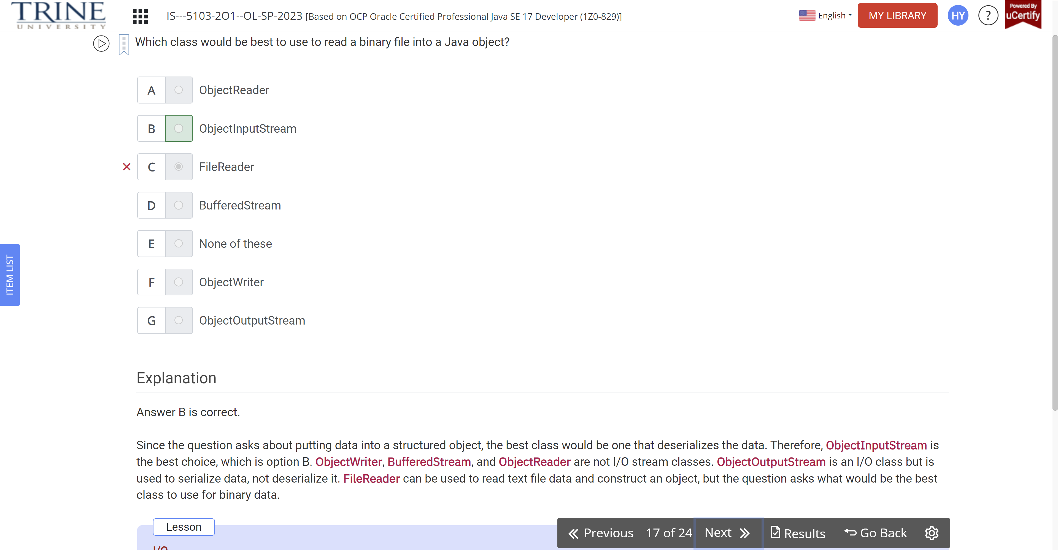

What is the output of the following code?

Var p1 = Path.of(/zoo/.bear …)

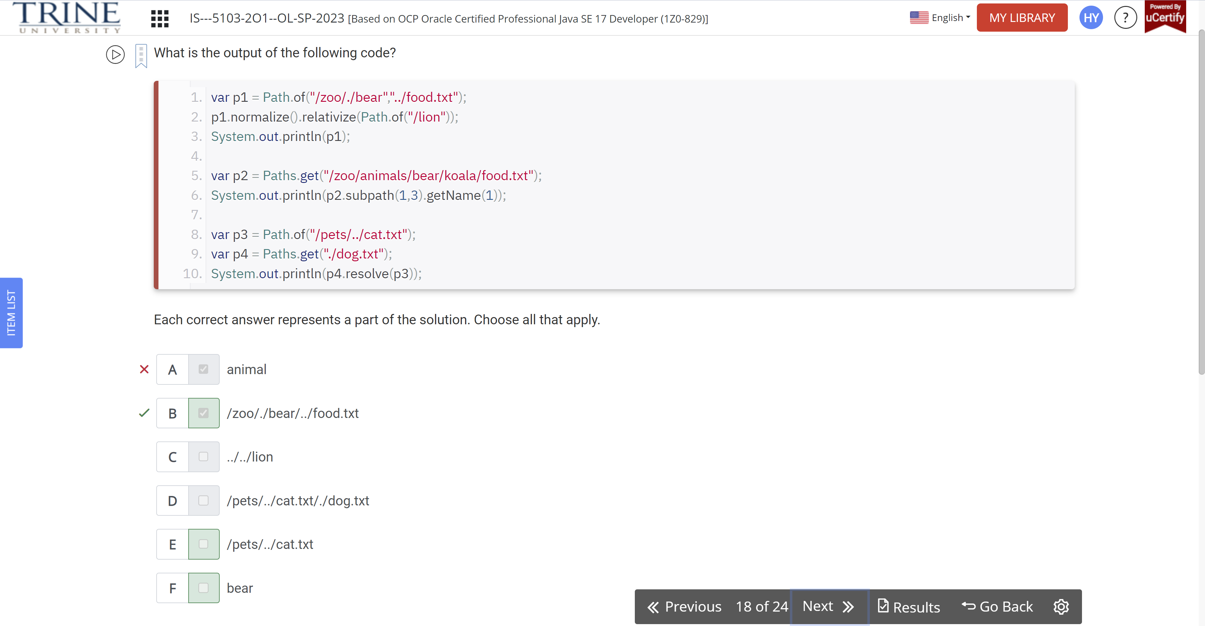

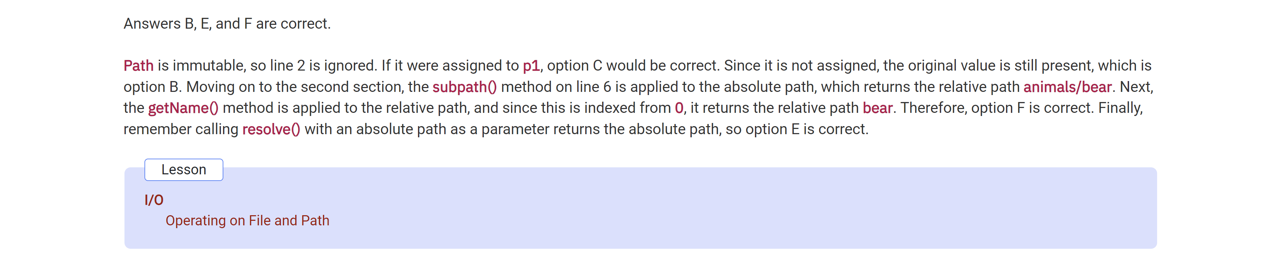

Assuming that the /fox/food-schedule.csv file exists … printData() …

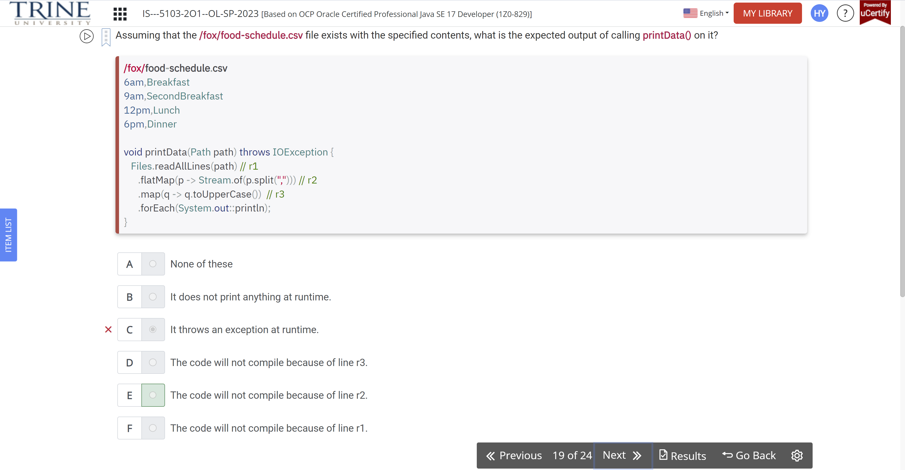

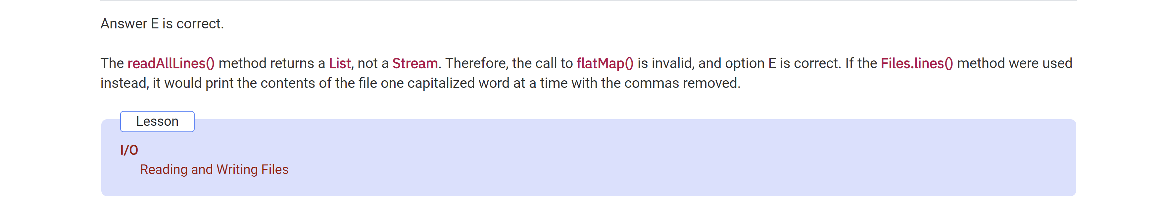

Assume that the source instance … /flip/sounds.txt …

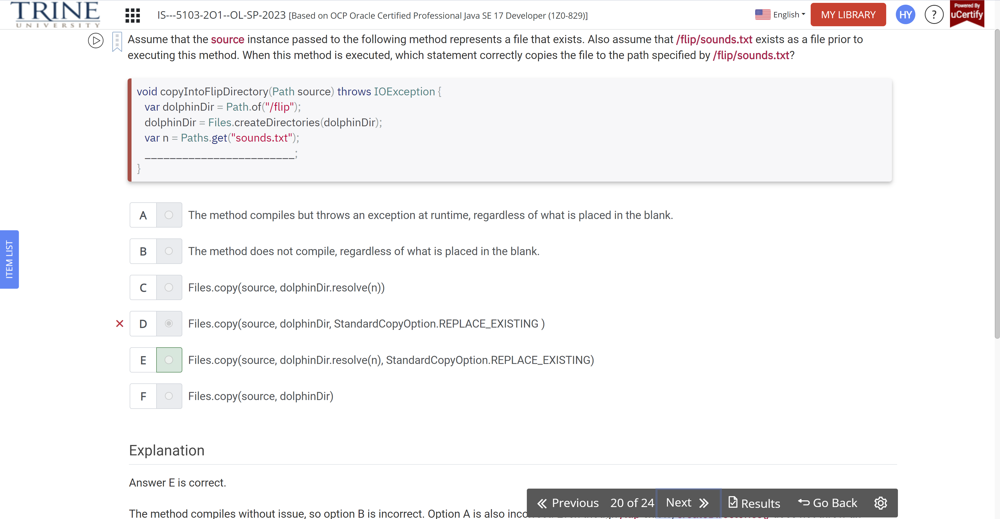

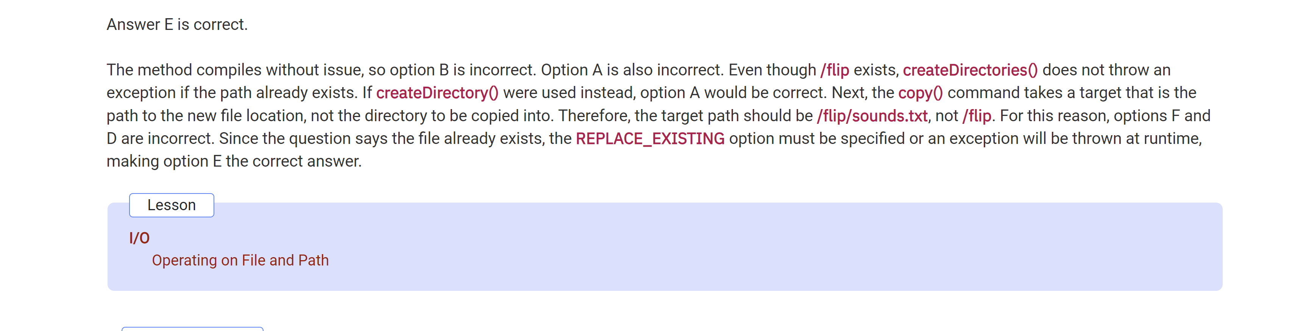

What is the result of executing the following code?

Var p = Paths.get(“sloth.schedule”);

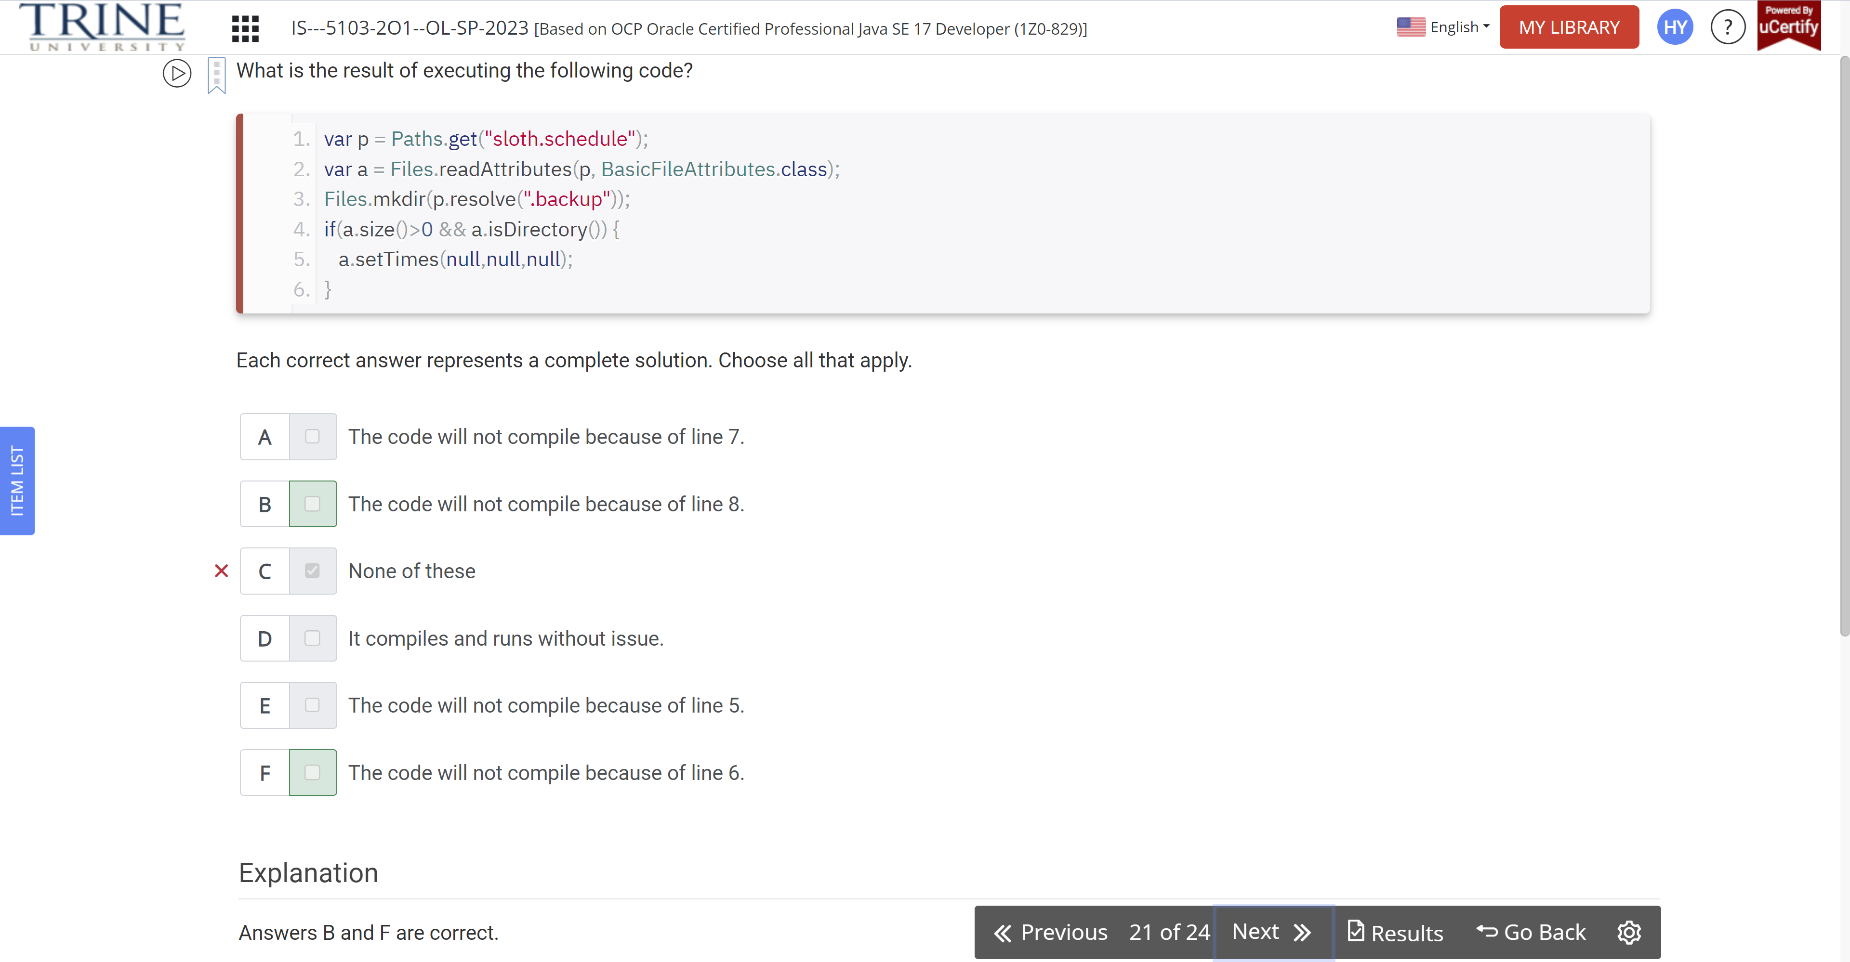

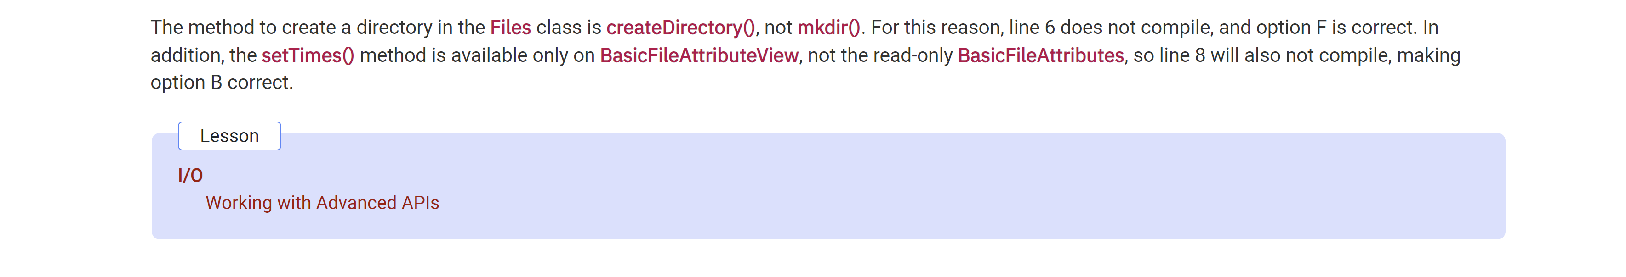

Suppose that the working directory … /weather …

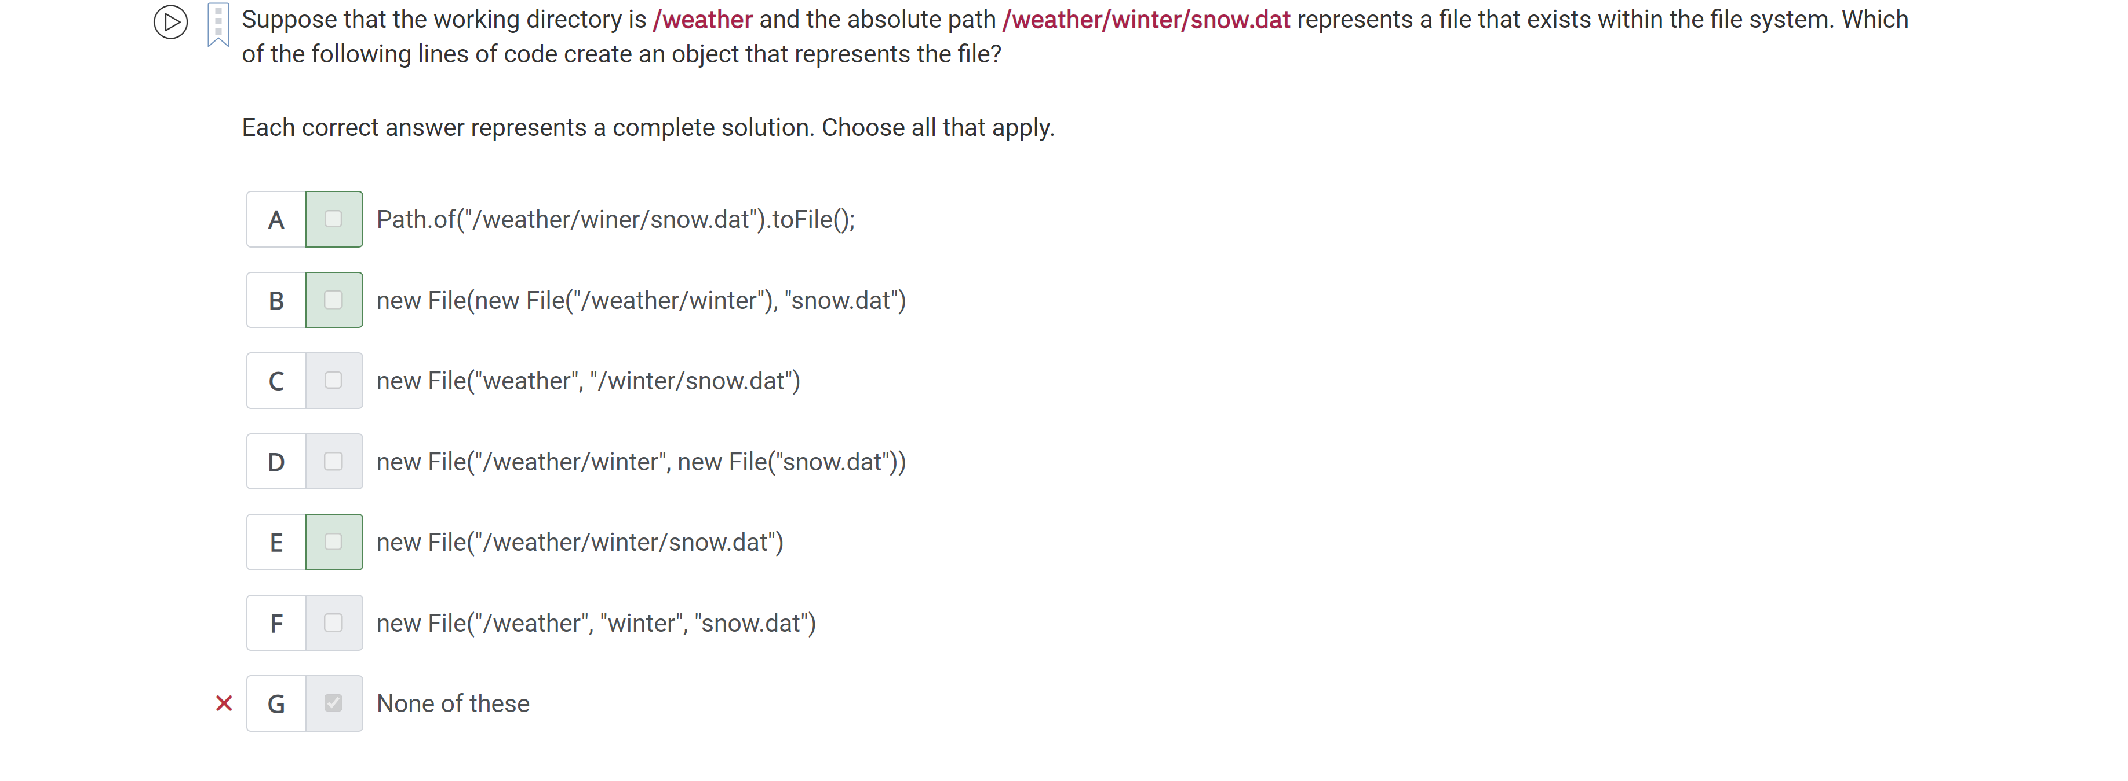

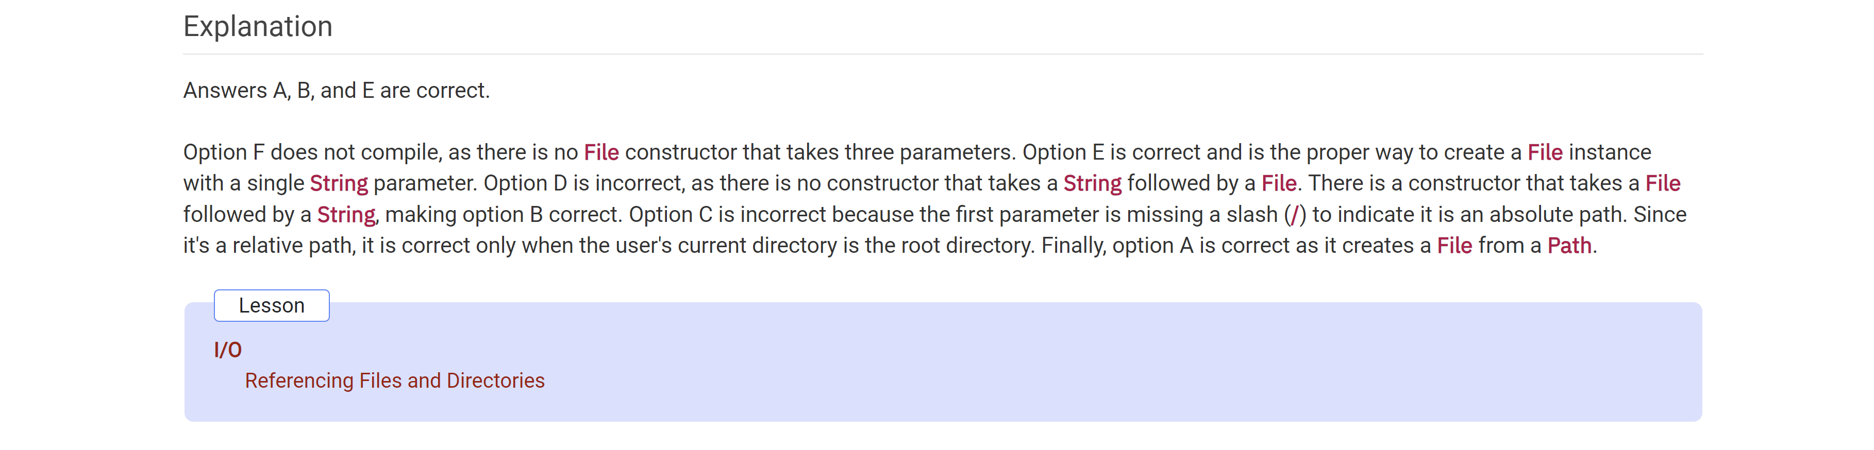

Assume that /kang exists as … /mammal/kangaroo

Var path = Paths.get(/kang)

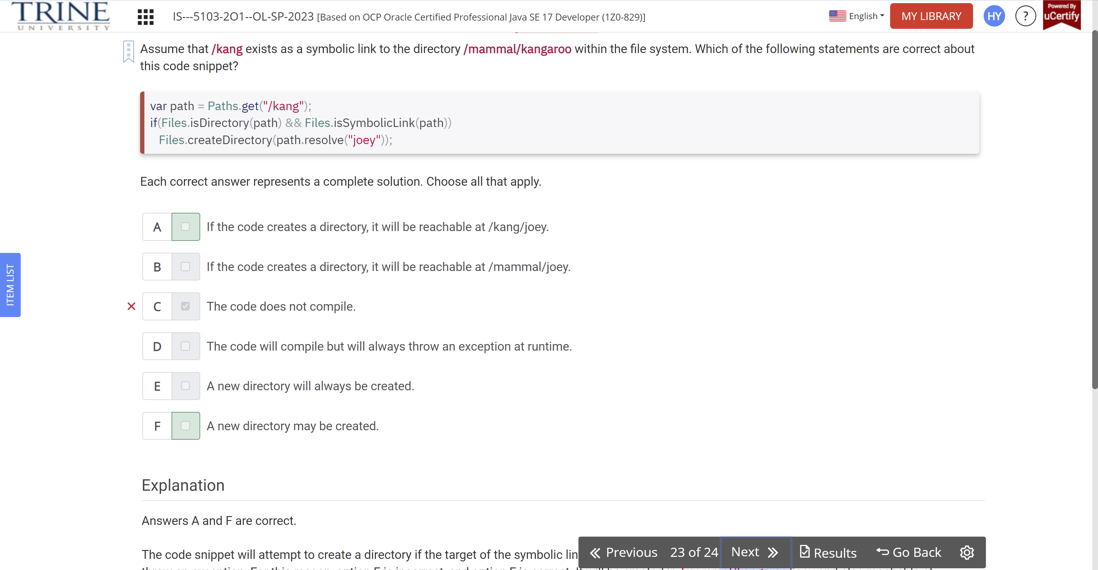

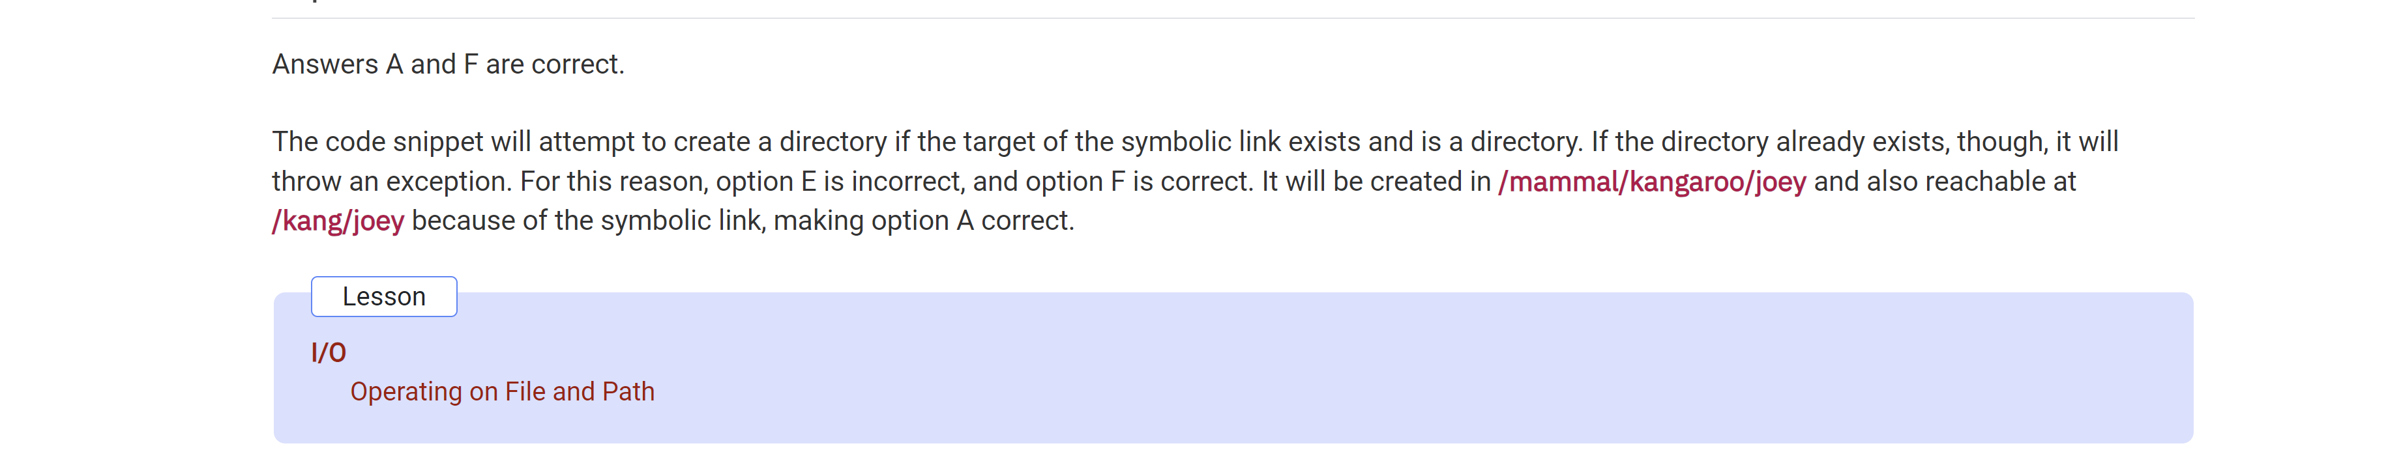

Assume that monkey.txt …

